Team City Pipelines

Contents

3. Project Outline
4. Deployment Process
6. Conclusion

Project outline:
I was given a ticket to add a new brand to team city pipelines. This brand was ‘Bank of Scotland’. Team city is a service that is involved in the deployment process. In a nutshell, it’s main function is to package code, its dependencies and tests ready to be deployed to live. Team city takes in code that has been pushed to master, in my case work committed to ‘My Account’. It then runs any tests included within the project and provided they pass moves onto completing security checks. Below you can find a high-level view of what team city does to get code ready for deployment:
Main steps:
- Takes code from master
- Fires off the build
- Cleans the solution, removing unnecessary files
- Builds and complies
- Updates nuspec dependencies if required
- Project configuration
- N tests – runs all tests
- If all pass, pushes to Nexus and generates Url for usage.

As stated, my job was to add the My Account pipeline for the brand ‘Bank of Scotland’, thus enabling work completed to be deployed.

Deployment Process:

I began by editing the MyAccount project within team city and creating a new build configuration. I then manually completed the available field entering the project ID as BankofScotland, in line with company standards.
I also set the build configuration to BankofScotland (fig.1) and used a template called ‘Web test and pack’; which would outline the pipelines behaviour.
Fig 1: Build configuration Id

I then clicked ‘create’ to setup and began setting some project-specific settings in the next section. Next, I attached a VSC root in the version control settings and edited the checkout rules for the root. I referenced the relevant confluence page to ensure I entered the details correctly and entered the following into the text area(fig2):
Fig 2: VSC root text
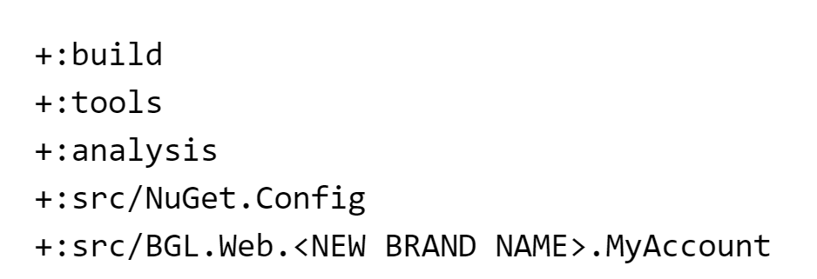

This concluded the first step in setting up the pipeline. Next, I configured Bank of Scotland ‘Deploy Feature to Development’. For this I found an existing ‘Deploy to Feature’ and cloned its settings, and simply altered the name fields to present BankofScotland instead.

Next, I needed to configure the Octopus Deploy. Octopus is my company’s main release system, which deploys the code to different environments; therefore, I added this as the create release setting in team city and set its value to (fig 4):
Fig 4: Octopus Deploy command line arguments

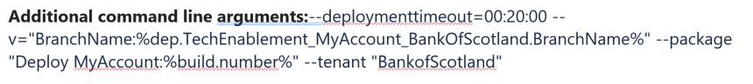

I also reset the build counter to 1 to prevent a mismatch of information after deployment. Finally, I configured the dependencies that this brand would be using. In figure 5 you can see the final settings.

Fig 5: Development final step.

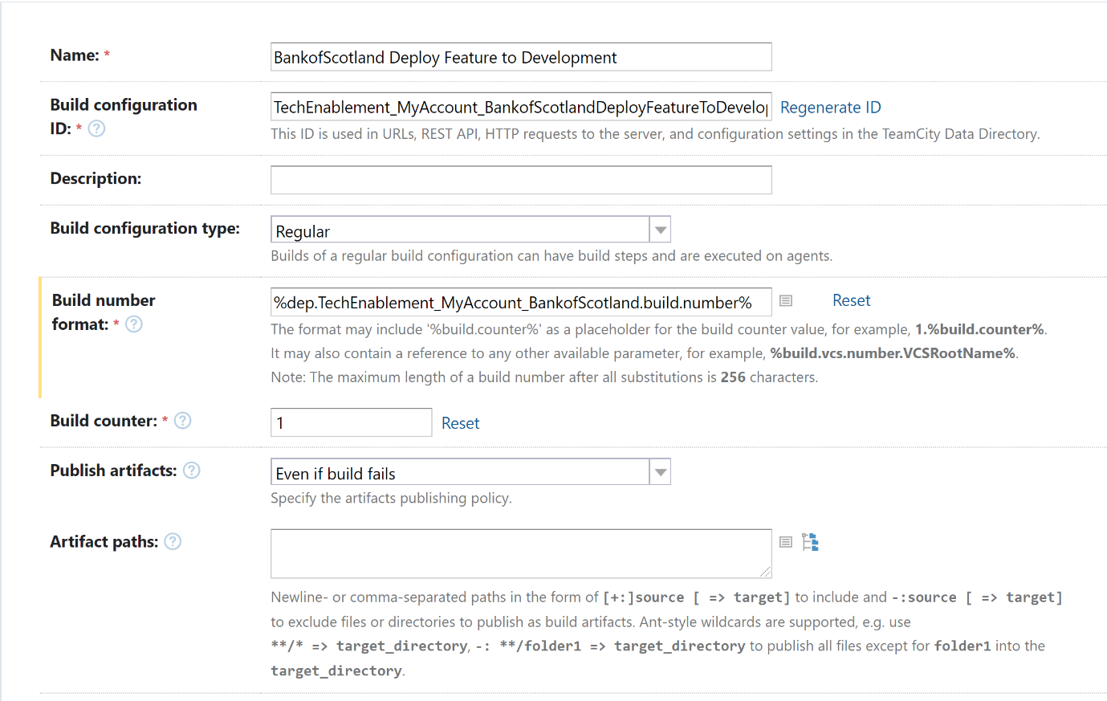
The last stage was setting up Bank of Scotland for the integration pipeline. This followed the same steps above with some minor changes.
- Clone pre-existing ‘Deploy feature to Integration’ build
- Change the name field to ‘BankofScotland’ Deploy Feature to Integration
- Reset the build counter to one
- Set the build number format to (fig 6):
Fig 6: Build number format
:%dep.TechEnablement_MyAccount_BankofScotland .build.number%

Below is a sample of the final pipeline setup for the integration stage.
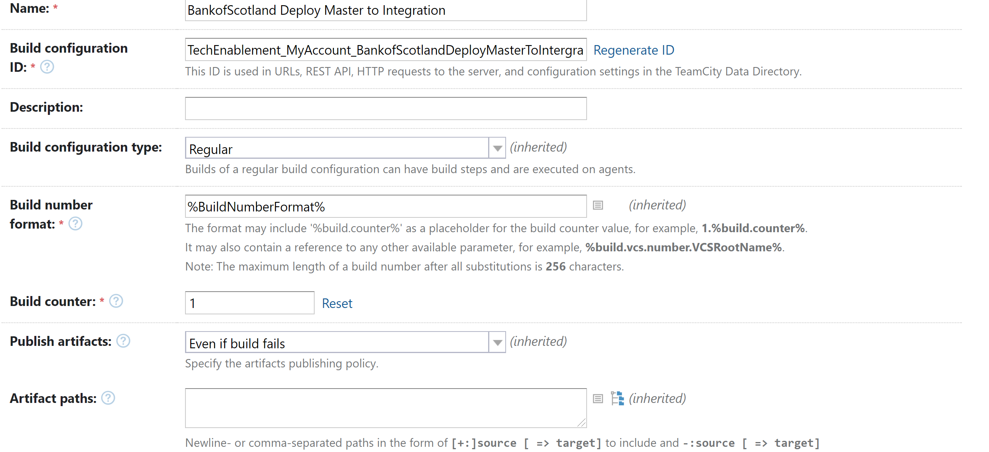

Conclusion
With this complete, my ticket was concluded. This was a relatively straightforward piece of work, but one that is essential to my company’s deployment process. Setting up this brand pipeline will allow its new My Account work, completed by other developers to safely move through my company’s deployment process. By setting this up any code will be automatically tested for security weaknesses before being pushed up to my company’s Nexus; ensuring safe and high-quality deployments.

